**2018年全国职业院校技能大赛**

**赛项申报书**

赛项名称：职业英语技能

赛项类别：常规赛项√ 行业特色赛项□

赛项组别：中职组√ 高职组□

涉及的专业大类/类：财经商贸类

方案设计专家组组长：

手机号码：

方案申报单位（盖章）：

中国职业技术教育学会教学工作委员会

全国基础外语教育研究培训中心

方案申报负责人：

方案申报单位联络人：

联络人手机号码：

电子邮箱：

通讯地址：

邮政编码：

申报日期：2017年8月30日

**目 录**

一、赛项名称 1

二、赛项申报专家组 2

三、赛项目的 3

四、赛项设计原则 3

五、赛项方案的特色与创新点 4

六、竞赛内容简介 6

七、竞赛方式 6

八、竞赛时间安排与流程 8

九、竞赛试题 9

十、评分标准制定原则、评分方法、评分细则 46

十一、奖项设置 47

十二、技术规范 47

十三、建议使用的比赛器材、技术平台和场地要求 48

十四、安全保障 48

十五、经费概算 50

十六、比赛组织与管理 51

十七、教学资源转化建设方案 51

十八、筹备工作进度时间表 52

十九、裁判人员建议 53

二十、其他 53

**2018年全国职业院校技能大赛**

**赛项申报方案**

**一、赛项名称**

（一）赛项名称

2018年全国职业院校技能大赛中职组职业英语技能赛项

（二）压题彩照

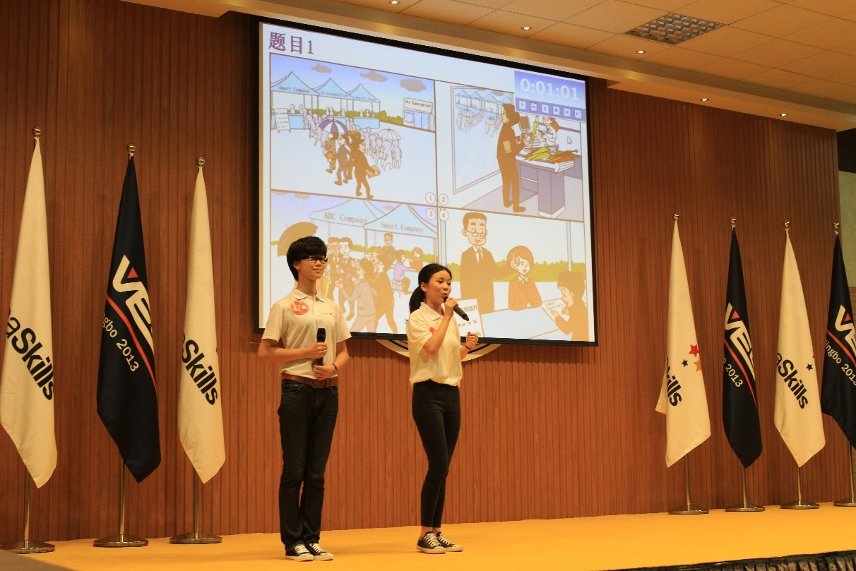

（三）赛项归属产业类型

财经商贸类

（四）赛项归属专业大类

财经商贸类

**二、赛项申报专家组**

**三、赛项目的**

以赛促学、以赛促教是本次大赛的目的。本赛项主要考核中职学生在通用职场情境下运用英语的综合能力及基本职业能力。

赛项着力于中职学生创新能力、思辨能力、沟通能力及职场竞争力的综合培养，服务于中职英语教学改革的发展需求，旨在为全国中职学生及英语教师创建一个交流学习、拓展视野、展示才华的平台，推动中职英语教学模式和人才培养方式转变，展现中职学校英语教学改革成果。

**四、赛项设计原则**

（一）公开、公平、公正原则

本赛项将在赛前公开竞赛方式、竞赛流程、评分方法，并在赛前一个月在大赛官网上公布竞赛试题或竞赛技能点；比赛过程全程录像。每支参赛队临场接题，封闭备赛，规避了选手接受场外援助的可能。在公平和不干扰比赛选手的前提下开放比赛过程。

本赛项裁判人员由职业英语教学专家、英语测评专家、母语为英语的外籍专家、知名企业人力资源部负责人共同组成。所有裁判经过专门的培训。赛项评分细则准确、细致，比赛现场亮分，确保比赛的公平、公正。

（二）普适性原则

本赛项面向全国中等职业学校所有专业的学生，旨在通过本赛项的开展引领中职英语教学改革，将对基本职业能力的重视辐射到中职教育教学中去。

（三）综合考核原则

通用职场情境下运用英语的综合能力是本赛项所考查的核心内容，展示选手的英语听说读写能力及跨文化交际能力，这些能力也是所有在工作中使用英语的人员所必备的能力；本赛项所考查的另一项内容是包括创新、思辨、沟通、信息处理、合作、解决问题等能力在内的基本职业能力，具备上述能力及精神的从业人员在任何岗位上都会更受欢迎。

（四）竞赛平台成熟原则

本赛项于2012、2013、2015、2016、2017年成功举办了五届（根据大赛规划于2014年休赛一年）。在前五届比赛成功举办的经验基础上，本赛项从考查内容、考查方式到比赛流程、赛后的资源转化方面都进行了优化，以更好地实现本赛项“以赛促教、以赛促学”的目的。

本赛项在线测评环节采用成熟的“语言测试与训练系统”。该系统成熟、运行稳定，已成功应用于前五届国赛及相关省/区/市级竞赛，本届比赛将继续为国赛提供全力支持。

**五、赛项方案的特色与创新点**

（一）赛项参与度广

由于英语的公共基础课性质，本赛项参赛选手几乎覆盖中职所有专业，本赛项对通用职场情境下运用英语的综合能力及基本职业能力的考查将对中职英语教学形成反拨作用，从而推动中职教育教学模式和人才培养方式的转变。

（二）赛项考查内容贴合企业需求

企业专家深度参与本赛项的赛程设计、赛题命制及评分执裁各阶段，保障比赛形式贴近职业情境，考查内容贴合企业需求。赛项竞赛内容与形式高度接近选手将来的工作场景，与其他英语竞赛注重考查英语语言水平不同，本赛项侧重考查选手在通用职场情境下运用英语表达思想、交流信息、完成任务的能力。根据现代服务业和制造业对中职毕业生的不同要求，本赛项分服务类和其他类两个组别对选手进行考查，考查标准根据选手实际水平及职场实际要求设置，契合中职选手能力层级及就业需求。比赛命题专家包括行业专家及职业英语教育专家，能更好地把握命题思路及考查内容和形式。

（三）扩大赛项影响，赢取关注支持

大赛裁判组由职业英语教学专家、英语测评专家、母语为英语的外籍专家、知名企业人力资源部门负责人构成，确保成绩评判权威性的同时，也通过不同领域专家的参与更好地宣传本赛项，扩大赛项影响。

比赛赛程对观众公开，多渠道传播本赛项的理念，展现中职学校英语教学改革成果，增强中职学生学习英语的信心，提高其学习英语的兴趣，获得社会各界对职业教育更多的关注和支持。

（四）深度转化、推广竞赛成果

将赛题题库整理成册，作为中职学校学生英语技能培训、提高的教材。通过举办竞赛，呼吁建立职业英语能力测评的相关国家标准和行业标准，引导中职学校英语教学与相关标准保持一致。依托中国职业技术教育学会、全国基础外语教育研究培训中心和《中国外语》核心期刊等机构和媒体，更好地推广竞赛成果。

**六、竞赛内容简介**

职业英语技能赛项包括在线测评、情境交流、职场应用三个环节。本赛项考查参赛选手在通用职场情境下运用英语进行听、说、读、写的综合英语应用能力，跨文化交际能力，以及最基本的创新、思辨、沟通、合作、信息处理、解决问题等职业能力。(详见“七、竞赛方式”)

Vocational English Skills Competition comprisesthree stages: Online Evaluation, Communication in Simulated Scenarios, and Professional Application. In Online Evaluation, contestants take a vocational English competency test on computers. In Communication in Simulated Scenarios, each team is given a set of pictures; one contestant on the team describes its content and the other contestant answers related questions posed by the question master. In Professional Application, each team gets a workplace task and work together to fulfill it; after that, one contestant describes how his/her team has accomplished the task and the other contestant answers related questions posed by the question master.

**七、竞赛方式**

（一）组队要求

1. 本赛项为团体赛，分服务类专业组和其他类专业组两个组别。

2. 参赛队以院校为单位组队参赛，不得跨校组队。一支参赛队仅可参加一个组别的比赛。每支参赛队由2名选手和2名指导教师组成。“情境交流”和“职场应用”环节，各队选手按A、B角色分工完成比赛。

3. 各省（自治区、直辖市）参赛队分配数以全国大赛执委会通知为准。

4. 本赛项不邀请国际团队参赛，欢迎国际团队观摩。

（二）竞赛方式

本赛项在线测评、情境交流、职场应用三个环节的具体竞赛流程如下：

1.在线测评

选手上机操作，使用成熟的“语言测试与训练系统”，在线测评通用职业场景下的英语综合语言应用能力。每支参赛队2名选手卷面成绩的平均分乘以相应系数为此环节最终成绩。本环节限时1小时，满分20分。

2.情境交流

选手以2人团队为单位参加此环节竞赛。每队拿到一组图片，图片呈现一个工作任务或事件，内容和场景与选手生活或将来的工作紧密相关。经过30分钟的准备后，一名选手在90秒内用英语对图片内容做出描述并阐释个人见解，另一名选手与裁判就图片主题及描述内容进行90秒的互动问答。本环节满分40分。

3.职场应用

选手以2人团队为单位完成一个通用职业场景中的工作任务。竞赛过程分为两个阶段：第一阶段在备赛室进行，选手取得任务后，在30分钟内通过分工协作完成该任务；第二阶段在赛场内进行，一名选手在3分钟内向裁判陈述任务完成情况，另一名选手在2分钟内回答裁判就任务主题及完成情况提出的相关问题。整个过程要求使用英语沟通交流。本环节满分40分。

**八、竞赛时间安排与流程**

|  |  |
| --- | --- |
| **日程安排** | |
| 第一天 | |
| 08:30-09:00 | 开幕式 |
| 09:00-09:30 | 合影 |
| 09:30-10:30 | 竞赛预备会 |
| 10:50-11:50 | 在线测评 |
| 13:30-17:00 | 情境交流 |
| 第二天 | |
| 08:30-12:00 | 职场应用 |
| 13:30-17:00 | 闭幕暨颁奖式 |

**九、竞赛试题**

（一）服务类专业组样题

**在线测评环节**

本环节包括听力和阅读两部分，共80题。请在60分钟之内完成。

**Part I Listening 听力（20%）**

**Section A (10%)**

In this section, you will hear ten short dialogues and questions. There are three pictures marked A, B,and C for each question. Choose the one that best matches the question. Each dialogue and question will be read just once and you will have 15 seconds for each question.（在本节中，你将听到10个短对话和相应的问题，每道题配有A、B、C三幅图片，选出与题目内容相符合的一幅图片。每个对话和问题读一遍，每题有15秒钟的作答时间。）

（） 1. How will the man pay?

A.  B.  C. 

（）2. What does the man order for the main course?

A.  B.  C. 

（） 3. What has been the woman’s job?

A.  B.  C. 

（）4. Where might the conversation take place?

A.  B.  C. 

（）5. What kind of dressing does the man want on his salad?

A.  B.  C. 

（）6. What does the woman recommend?

A.  B.  C. 

（）7. What is Mr. Brown doing now?

A.  B.  C. 

（） 8. What doesn’t work?

A.  B.  C. 

（） 9. Where did the woman go in Los Angeles (洛杉矶)?

A.  B.  C. 

（）10. Where is Peter?

A.  B.  C. 

**Section B (5%)**

In this section, you will hear a dialogue. After the dialogue, five questions will be asked. There are threechoices marked A, B, and C for each question. Choose the one that best answers the question. The dialogue and questions will be read just once and you will have 15 seconds for each question.（在本节中，你将听到1段对话和5个相应的问题，每道题配有A、B、C三个选项，选出与题目内容相符合的一个答案。对话和每个问题读一遍，每题有15秒钟的作答时间。）

（）11. Mr. Cooper is _________________.

A. attending a dinner party

B. having dinner at a restaurant

C. buying some meat and vegetables in a store

（）12. What does Mr. Cooper order for his main course?

A. Chicken soup and a cheeseburger.

B. A steak and chicken soup.

C. A steak and a cheeseburger.

（）13. Mr. Cooper doesn’t order seafood because _________________.

A. he doesn’t like it

B. he doesn’t want to eat too much fatty food

C he wants to drink a cup of tea

（）14. Mr. Cooper ordered a cup of coffee _________________.

A. with sugar and cream

B. without sugar or cream

C. with only cream

（）15. In what order (顺序) does the woman take Mr. Cooper’s order?

A. starter, main course, seafood, desserts, and beverages

B. starter, seafood, main course, beverages and desserts

C. starter, beverages, main course, desserts and seafood

**Section C (5%)**

In this section, you will hear a dialogue. After the dialogue, arrange the following activities in the correct order. (在本节中，你将听到一段对话，根据对话中的内容给下列活动排序。)

a. tour around New York

b. be invited to a dinner party

c. go shopping

d. watch a Broadway show

e. attend a trade fair

（）16-20. The correct order of the activities is _______________.

A.b — e — a — c — d

B. e —b—a— c — d

C. e — b — a — d — c

D. d — c — a — b — a

**Part II Reading 阅读（80%）**

**Section A (20%)**

In this section, you will read 20 short dialogues or pictures. Choose from A, B, and C the choice that best completes the dialogue or sentence. （在本节中，你将读到20个短对话或图片，从A、B、C三个选 项中选出能够补全对话或句子的最恰当的选项。）

（）21. — I hear you are going to Hong Kong next Monday. How are you going there?

—_________________.

A. For sightseeing (观光).

B. By sea.

C. On June 8.

（）22. — I am new in London. Could you recommend some interesting places to visit?

—_________________.

A. How about Big Ben and Tower Bridge?

B. Do you enjoy your stay here?

C. What’s your plan for this trip?

（）23. — This bus goes to the Fifth Avenue, doesn’t it?

—_________________.

A. Yes. Who are you waiting for?

B. Yes. When do you come back?

C. Yes. Where do you want to go?

（）24. — This computer doesn’t work. I want my money back.

— Sorry, madam, _________________.

A. we like playing computer games.

B. you can only change it for a new one.

C. the computer is useful to our life and work.

（）25. — _________________.

— Where are you flying from and to?

A. I’d like to book two plane tickets.

B. I’d like to book two tickets for the football game.

C. I’d like to book two tickets for tonight’s movie.

（）26. — Are you having a Super Saver Special today?

—_________________.

A. All right. Could you wait a moment, please?

B. That’s right. You can get an ice-cream for free when you order two burgers.

C. That’s all right. What would you like to order?

（）27. — May I have your ticket and passport, please?

—_________________.

A. Sure. Please help yourself.

B. Sure. Choose whatever you want.

C. Sure. Here you are.

（）28. — Reservation desk, may I help you?

—_________________.

A. Hello, I’d like to book a single room with a bath from July 2 to 5.

B. Hello, I’d like to open a checking account.

C. Hello, I’d like to change some US dollars to RMB.

（）29. — I reserved a non-smoking room, but this one is not.

— I’m very sorry, sir. _________________.

A. I’ll check with the bellman right away.

B. I’ll manage to change a room for you.

C. I’ll send a repairman right away.

（）30. — I’m the bellman here. Let me help you with your luggage.

— Thanks. _________________.

A. At your service.

B. With pleasure.

C. It’s very kind of you.

（）31.



If you park your car for 40 minutes, you need to pay _________________.

A. ￡1

B. ￡2

C. ￡4

（）32.



This sign tells you that _________________.

A. a man falls on the floor

B. you should be careful while walking on the wet floor

C. the wet floor is in danger

（）33.

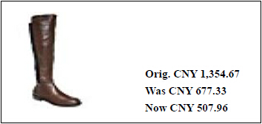

If you want to buy two pairs of high boots of this kind, you need to pay _____________.

A. CNY 1354.67

B. CNY 1354.66

C. CNY 1015.92

（）34.



You can buy _________________.

A. a bone-out chicken wing with 50 yuan this Wednesday

B. a bone-out chicken wing with 50 cents on Wednesday

C. a plateful of bone-out chicken wings with 50 cents every Wednesday

（）35.

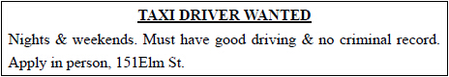

This is a (an) _________________ad.

A. employment

B. car rental

C. car wash

（）36.



You go to _________________with this ticket.

A. watch a concert

B. see a movie

C. visit a museum

（）37.



When drivers see this sign, they need to _________________.

A. stop

B. turn around

C. drive slowly

（）38.



These signs encourage you to be _________________.

A. good drivers

B. good readers

C. good passengers

（）39.



You can _________________.

A. bring your cat here

B. take a guide dog with you here

C. play with a monkey here

（）40.



You can’t . _________________.

A. eat or drink by the swimming-pool

B. swim after much eating and drinking

C. find anything to eat or drink in pool area

**Section B (10%)**

In this section, you will read 2 dialogues. For each blank, choose from A, B, C, D, and E the expression that best completes the dialogue. (在本节中，你将读到2段对话，从A、B、C、D、E五个选项中选出能够补全对话的最恰当的选项。)

*Dialogue 1*

A. for an interview B. take a message C. as soon as

D. Hold on E. attend a meeting

A: Hello, this is David Parker, manager of human resources department. May I speak to EricBrown?

B: ___41___, please. I’m sorry; he is not in at the moment.

A: Could you ___42___, please?

B: Sure.

A: Could you please tell him to come to my office ___43___ at 10:30 am tomorrow? I wassupposed to meet Eric at 9 am, but I would have to ___44___, so I need to change the interviewtime to 10:30 am. Tell him I feel sorry about that.

B: Change the interview time to 10:30 am, and say sorry to Eric. All right, I’ll tell him ___45___he comes back.

A: Thank you so much.

*Dialogue 2*

A. look at B. fill in C. different from

D. rate of exchange E. at the bottom

A: Good morning, sir. What can I do for you?

B: Morning. I’d like to change 500 US dollars into RMB. What’s today’s ___46___?

A: 6.35Yuan RMB to one US dollar. You may ___47___ the Electronic Rate Board over there.

B: Oh, I see. Thank you. It’s a little ___48___ the rate when I changed RMB into US dollars.

A: Could you please show me your passport?

B: Here it is.

A: Thanks. Please ___49___ this form.

B: All right.

A: Please sign ___50___ of this form. … Here is your money; and your passport.

**Section C (10%)**

The following notice shows a list of sections in a hotel. Decide which section each guest needs to visit. (下面是某宾馆的各部门列表，将宾馆客人所需要的服务与各部门相匹配。各部门名用字母A—L表示。)

A. Foreign Exchange Counter

B. Food and Beverages Department

C. Front Desk

D. Housekeeping

E. Hairdresser’s Parlor

F. Recreation Center

G. Maintenance Department

H. Administration and HR

I. Event Management

J. Business Center

K. Laundry Service

L. Transportation

（）51. The Greens are having dinner.

（）52. The air conditioner in Mrs. Wood’s room doesn’t work.

（）53. Mr. Lin wants to change some RMB for US dollars.

（）54. Miss White applies for a receptionist’s job.

（）55. Mr. Carter, the boss of a company, is going to hold a conference in the hotel.

（）56. Guests have their clothes washed and ironed.

（）57. Mr. Gray’s room needs cleaning.

（）58. The Blacks play bowling.

（）59. Guests check in and check out.

（）60. Mr. Smith needs to send a fax to his assistant.

**Section D (40%)**

In this section, you will read four passages. After each passage, choose from A, B, and C the best answer for each question. （在本节中，你将读到4篇短文，从A、B、C三个选项中选出最佳答案。）

**Passage A**

Many people complained to the manager of a cinema that some ladies saw movies with their hats on and blocked (挡住) their view. They suggested the manager should put up a notice asking the ladies to take off their hats when seeing movies.

The manager said that it wouldn’t be reasonable to ask ladies to take their hats off, and that they wouldprotect their rights to wear their hats. The complainers were greatly disappointed.

But the next day, the following words appeared on the screen before the movie was on:

“Considering the health of ladies of old age, this cinema allows old ladies to wear their hats whileseeing movies.”

All the ladies took their hats off after they saw the amusing notice.

（）61. The complainers suggested that _________________.

A. the ladies should sit at the back of the cinema

B. the ladies should not be allowed to wear their hats when seeing movies

C. the ladies should have the right to wear their hats when seeing movies

（）62. The complainers were disappointed because the manager said that _________________.

A. he would take off the ladies hats

B. it was great for ladies to wear hats when a film was going on

C. he had no reason to ask ladies to take their hats off

（）63. The manager thought of a good idea to _________________.

A. protect the ladies’ rights

B. meet the complainers’ demand

C. allow old ladies to wear their hats

（）64. What do you think of the manager?

A. He is cold and rude.

B. He is foolish but friendly.

C. He is polite and clever.

（）65. The story tells us that _________________.

A. sometimes permission works more than prohibition (禁止)

B. old ladies should be taken good care of

C. ladies shouldn’t wear hats when seeing films

**Passage B**

**A Meeting Memo**

To: manager from Design Department, manager from Finance Department, manager from MarketingDepartment

From: Robert Brown, general manager

Subject: Meeting

Date: Thursday, Sept.6, 2012

We are to have a meeting in Conference Room 1006, on Thursday, Sept. 6, 2012. We shall discuss thedesign, budget of a new model of sports cars, and marketing strategies.

（）66. How many people are to attend the meeting?

A. 3.

B. 4.

C. 5.

（）67. Who sends the memo?

A. Manager from Design Department.

B. Manager from Marketing Department.

C. General Manager.

（）68. When and where is the meeting held?

A. In Conference Room 1006, on Thursday, Sept. 6, 2012.

B. In Conference Room 1008, on Thursday, Sept. 6, 2012.

C. In Conference Room 1006, on Tuesday, Sept. 6, 2012.

（）69. What is to be discussed at the meeting?

A. The design and budget of a new model of cars.

B. The design of a model of sports cars, and marketing strategies.

C. The design, budget of a new model of sports cars, and marketing strategies.

（）70. Who is mainly responsible for the budget?

A. Manager from Design Department.

B. Manager from Finance Department.

C. Manager from Marketing Department.

**Passage C**

New! Passengers traveling internationally can now use Online Flight Check-In.

We offer several flight check-in choices for your convenience and comfort. Please see the informationbelow to choose the best choice for you!

**Before the Airport**



Online Check-In

Using any desktop computer or laptop, you can check in one to 24 hours before departure for domestic (国内的) flights and two to 24 hours before departure for international flights.

Mobile Check-In

If you’re on the go, check in via AA.com Mobile. And, in selected cities, you can go green and use yourphone as your boarding pass, eliminating(免除) the need for paper!

**At the Airport**



Self-Service Check-In

Our airport Self-Service Check-In machines offer a quick and easy way to get your boarding pass andcheck your bags without waiting in line at the ticket counter.

Curbside (路边) Check-In

Check your bag and get your boarding pass right at the curb. No need to lug (费力拖曳) heavy baggage around the airport!

Ticket Counter Check-In

Our airport staff is happy to assist passengers traveling with babies or pets, customers with specialneeds, or anyone else wanting personal assistance with check-in.

（）71. Besides the new Online Check-in service, _________________other flight check-in services areoffered to passengers.

A. 3

B. 4

C. 5

（）72. According to the passage, the airline offers several check-in choices so that _________________.

A. passengers’ travel can be made as easy as possible

B. passengers’ travel can be made as exciting as possible

C. passengers’ travel can be made as colorful as possible

（）73. If you fly from Chicago to Beijing at 11 am on July 3, you need to check in online at _________________.

A. 10 am, July 3

B. 8 pm, July 2

C. 10 pm, July 1

（）74. Which of the following is TRUE?

A. When traveling internationally, you can check in with your mobile phone and can also useit as your boarding pass anywhere you like.

B. You can check in by using the Self-Service Check-In machines at the airport.

C. You can check in and get your boarding pass at the curb, but you have to check your bags atthe airport.

（）75. If you ask the airport staff to do the check-in for you, it is better for you to come to _________________.

A. the airport security check

B. the airport boarding gate

C. the airport ticket counter

**Passage D**

After graduation, Charlie and Jackie both joined a wholesale(批发) company.

Several years later, the boss made Jackie sales manager but Charlie was still a salesman. Charlie was very unhappy about it. One day he handed in his resignation letter (辞职信) to the boss and complained that it was unfair of the boss only to promote those who tried to please him.

The boss knew that Charlie worked very hard all these years, but in order to help Charlie see thedifference, the boss asked Charlie to go and find out if there was anyone selling watermelons in the market.Charlie went, returned and said, “Yes.” The boss asked, “How much per kilogram?” Charlie went back to themarket, asked the price and returned to answer, “$12 per kg.”

The boss told Charlie that he would ask Jackie to do the same. Jackie went, returned and said, “Boss,only one person selling watermelons. $ 12 per Kg, $ 100 for 10 Kg. Altogether he has 340 melons. On thetable are 58 melons, and every melon weighs about 15 Kg. They are fresh, red, and of good quality.”

Charlie realized the difference between himself and Jackie. He decided not to leave but to learn fromJackie.

My dear friends, you know, a more successful person is more observant (善于观察的), thinks more and understands more deeply. For the same matter, he sees several years ahead, while you see only tomorrow. Thedifference between a year and a day is 365 times, so how could you win?

（）76. What was the relationship between Jackie and Charlie?

A. Classmates.

B. Workmates.

C. Business partners.

（）77. Why did Charlie decide to give up his job?

A. Because he thought the boss was unfair to have promoted Jackie, instead of him.

B. Because he thought it was unfair for Jackie to please the boss.

C. Because he thought the boss was unhappy about him.

（）78. To help Charlie see the difference, what did the boss do?

A. He asked Charlie to go and find out if there was anyone selling watermelons in the market.

B. He asked Jackie to go and find out if there was anyone selling watermelons in the market.

C. He asked both Charlie and Jackie to go and find out if there was anyone sellingwatermelons in the market.

（）79. What was the difference between Charlie’s and Jackie’s ways of doing the job?

A. Charlie did what the boss asked him to do, while Jackie gave more useful information than that.

B. Jackie knew more than Charlie about how to please his boss.

C. Charlie realized that he was not as able as Jackie.

（）80. What can we learn from the passage?

A. We can win if we know there are 365 days in a year.

B. We can be more successful if we are more observant and more far-sighted.

C. We can understand why Charlie decided not to leave the company but to learn from Jackie.

**参考答案**

1. A 2. A 3. B 4. C 5. C

6. A 7. C 8. B 9. C 10. A

11. B 12. C 13. A 14. B 15. A

16. - 20. B

21. B 22. A 23. C 24. B 25. A

26. B 27. C 28. A 29. B 30. C

31. B 32. B 33. C 34. B 35. A

36. A 37. C 38. B 39. B 40. A

41. D 42. B 43. A 44. E 45. C

46. D 47. A 48. C 49. B 50. E

51. B 52. G 53. A 54. H 55. I

56. K 57. D 58. F 59. C 60. J

61. B 62. C 63. B 64. C 65. A

66. B 67. C 68. A 69. C 70. B

71. B 72. A 73. B 74. B 75. C

76. B 77. A 78. C 79. A 80. B

**情境交流环节**

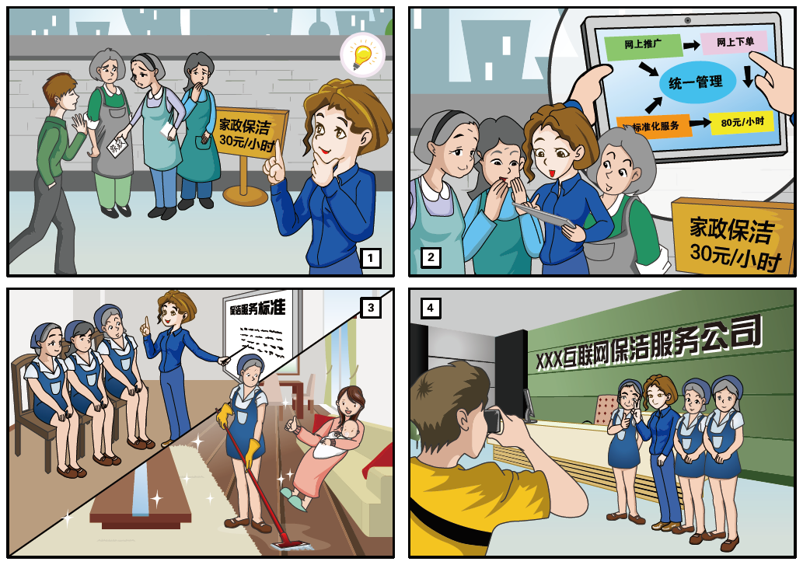

**职场应用环节**

**For Contestant A Only**

选手A：你是某家用电器的经销商，专营各种家用电器的批发零售。你收到了一位学生创业者的询价，他打算开一家低成本的小咖啡厅并想为咖啡厅的厨房采购电器设备。你的队友是你的合作伙伴，他给出了三个采购方案，请你根据客户的要求与队友商讨，选择最佳的电器设备采购方案。

在任务第一阶段（30分钟内），你需要完成：

1. 阅读对咖啡厅电器设备的需求，提取相关信息；

2. 向队友询问各电器方案的功能特点、价格等信息，根据要求完成任务单；

3. 与队友讨论，选出最佳的电器采购方案；

4. 准备第二阶段的汇报内容。

备注：任务单仅由选手A填写。

在任务第二阶段（3分钟内），你需要汇报任务完成情况，内容须涵盖以下几个要点：

1. What is your group’s task?

2. Which project for electrical appliances do you choose?

3. Why do you choose this project? And please give the reasons for choosing these electrical appliances.

**Here’s the information from your customer.**

Wang Lin is a college student, and his dream is to have his own café. Luckily, he has found a good place and his parents agree to help him with the money. Now, his dream café is opening soon. However, he has to choose the right electrical kitchen appliances at low prices with good functions, since he has only 30,000 yuan left. He says he’d like to offer various kinds of coffee, and hope to get a coffee machine that is easy and efficient to operate. Drinks like fresh juice, milk shake will also be available there, so a blender is needed. By the way, his kitchen is not a big one.

And the freezer must be no wider than 80 cm.

**Worksheet**

**Section 1 Communicate with Contestant B and complete the followingform.**

|  |  |  |  |
| --- | --- | --- | --- |
| **Project** | **Total cost** | **The coffee machine is easy and efficient to use. (Yes/No)** | **The size of the refrigerator** |
| Project A |  |  |  |
| Project B |  |  |  |
| Project C |  |  |  |

**Section 2 Discuss with Contestant B and choose the best project.**

**Your choice: ___________________________**

**For Contestant B Only**

选手B：你是某家用电器的供货商，你手上有三份针对咖啡厅所需而制订的电器配置方案。你的队友是你的合作伙伴，他收到了一份大学生创业者的询价，请与你的队友进行沟通，根据该客户的实际需求，为他选择最佳的电器设备采购方案。

在任务第一阶段（30分钟内），你需要完成：

1. 询问队友客户对电器方案的需求信息；

2. 与队友沟通，向其提供所需信息，协助队友完成任务单；

3. 与队友讨论，为客户选出最佳的电器采购方案；

4. 准备第二阶段的问答内容。

备注：任务单仅由选手A填写。

在任务第二阶段（2分钟内），你需要回答外籍裁判现场提出的3个问题。回答须与实际任务相结合，观点鲜明，有理有据，逻辑性强。

**Read the three projects of electrical appliances and help Contestant Acomplete the Worksheet.**

**Project A**

The SZ Coffee Machine: Italy Coffee System can make expresso, latte, cappuccino, hot chocolate and teas very quickly with true ease of use. All you need is to press the button. Price: ¥19,050

The Philips 220 Blender: With this blender, you can make fruits, beans, or ice. You may also like to make delicious juice and milk shake. Price: ¥2,800

YH-5 Double Door Refrigerator: It has large room for keeping food fresh. It can also freeze strongly. Dimensions: (L x W x H: 600 x 720 x 1570 mm). Price: ¥5,350

**Project B**

The Royal Coffee Machine: You can make all kinds of coffees with it, but the time will be longer. Price: ¥15,600

The Philips 990 Blender: This blender will give you better opportunity to make homemade juices. Price: ¥1,280

K-3 Refrigerator: This machine is an ideal machine for deep freezing all kinds of food and materials, being mini and having the wheels. Price: ¥3,000

**Project C**

The SZ Coffee Machine: Italy Coffee System can make expresso, latte, cappuccino, hot chocolate and teas very quickly with true ease of use. All you need is to press the button. Price: ¥19,050

The Philips 110 Blender: This blender allows you to create many kinds of drinks like juice and milk shake with the turn of a knob. It’s flexible and creative. Price: ¥7,800

Inter-75 Refrigerator: This refrigerator has a large capacity and the temperature range is between 0°C ~ 7°C for cooling and keeping freshness. Dimensions: (L x W x H: 900 x 800 x 1670mm). Price: ¥6,700

Note: L=length W=width H=height

（二）其他类专业组样题

**在线测评环节**

本次考试包括听力和阅读两部分，共55道题目。请在1小时之内完成。

**Part I Listening听力（40%）**

**Task 1**

**Directions:** *In this section, you will hear 10 short sentences and questions. There are three pictures marked A, B and C for each question. Choose the picture that best matches the question. Each sentence and question will be read out twice. You will have 10 seconds for each question.（在本节中，你将听到10个句子和相应的问题，每道题配有A、B、C三幅图片，请选择与题目内容相符合的一幅图片。每道题读两遍。每题你将有10秒钟的作答时间。）*

1. 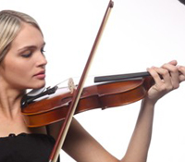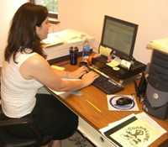

A B C

2.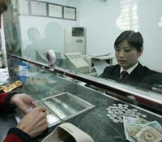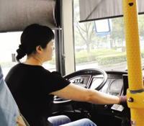

A B C

3. 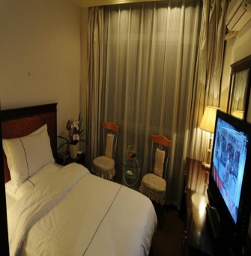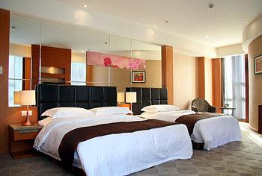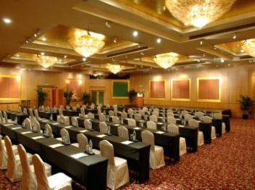

A B C

4. 

A B C

5. 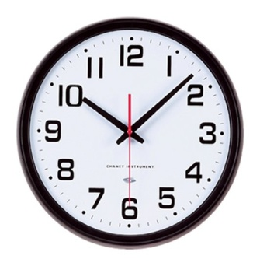

A B C

6. 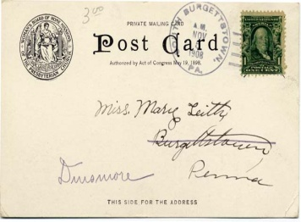

A B C

7. 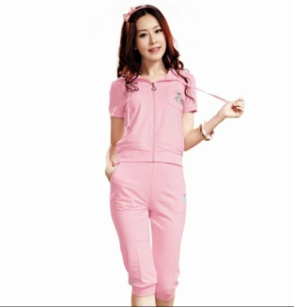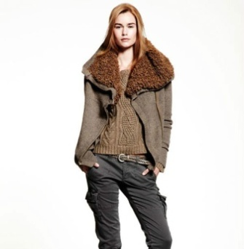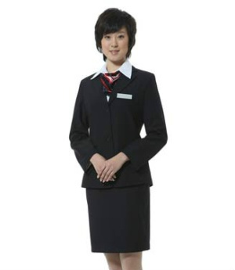

A B C

8. 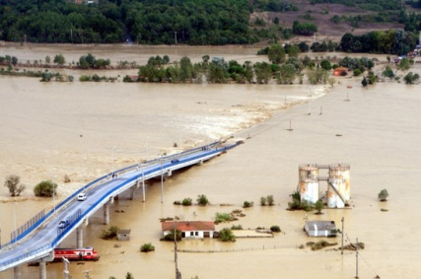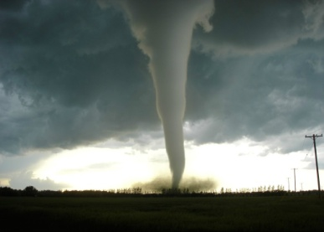

A B C

9. 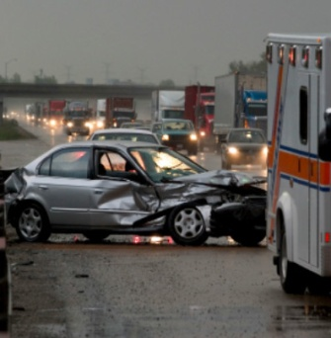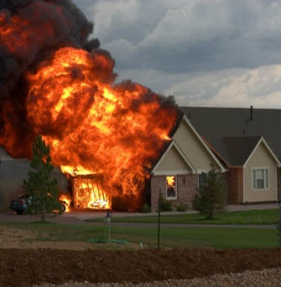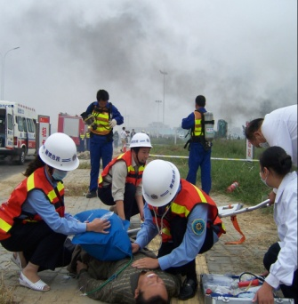

A B C

10. 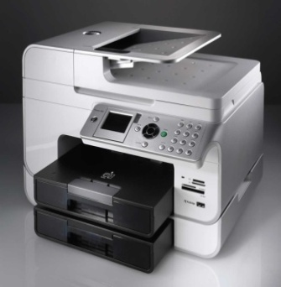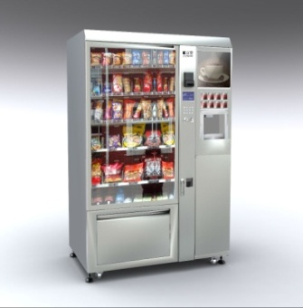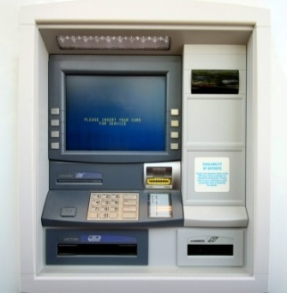

A B C

**Task 1 Transcripts:**

1. W: I am exhausted by searching for the latest information of that project on the Internet.

M: What has the woman been doing all day?

2. W: Amy is a cashier in a shopping centre and she starts to work at nine in the morning.

M: What does Amy do?

3. W: Catherine will travel abroad on her own next week. She is calling to book a room.

M: Which room does Catherine most probably book?

4. W: My daughter isn’t feeling very well now. I have to go to the drug store.

M: What does the woman want to buy?

5. W: Hurry up! It’s 8:30. We only have half an hour to dress up before the party starts.

M: When does the party start?

6. W: This Friday is Mary’s birthday. I want to send her a card.

M: Which card will be sent by the woman?

7. W: Judy is going to have a job interview. She wants to wear something formal.

M: What does Judy want to wear?

8. W: Our village was destroyed by the flood and many people lost their homes.

M: What was the disaster?

9. W: Call 119 as soon as possible if you find the fire is out of control.

M: What kind of emergency does the woman talk about?

10. W: Do you know where I can copy these documents? I need to get them ready before lunch.

M: What is the woman looking for?

**Task 2**

**Directions:** *In this section, you will hear a dialogue. Match the information according to what you hear and fill in the brackets with the letters. Notice there are two extra pieces of information you do not need. The dialogue will be read out twice. You will have one minute to complete the task. There is one example.（在本节中，你将听到一段较长的对话。请根据对话内容匹配信息，并将与信息对应的字母填在括号内。注意有两条冗余信息。对话读两遍。你将有1分钟的作答时间。请参照示例。）*

|  |  |  |  |  |
| --- | --- | --- | --- | --- |
| Example: 0. | Winnie | E | A | mechanic |
| 11. | Jack |  | B | salesman |
| 12. | Ben |  | C | manager |
| 13. | Johnson |  | D | secretary |
| 14. | Betty |  | E | receptionist |
| 15. | Carol |  | F | driver |
|  |  |  | G | cleaner |
|  |  |  | H | insurance agent |

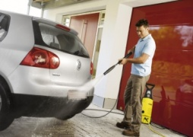

**Task 2: Transcripts:**

W: Morning. I’m Blair, a new employee of TAC 4S store.

M: Welcome to our company. I’m Mark. Let me show you around and let you get to know our colleagues.

W: That’s great. Thanks.

M: Look at the lady behind the front desk. She is Winnie, the receptionist of our company. Her job is to answer the telephone and arrange appointments.

W: She looks nice.

M: Look at Jack, the gentleman beside the red car. Jack is from the Sales Department of our company. He can always figure out the target customer’s needs and make the deal.

W: Wow, he’s wonderful.

M: Can you see Ben, the man talking with a couple?

W: Yes.

M: Ben is an insurance agent. He is employed by the insurance company to decide how muchto pay people who have had a vehicle accident.

W: Who’s the man over there?

M: He is Johnson, the mechanic. He’s responsible for checking and repairing cars.

W: Who’s the girl with the headphone?

M: She is Betty, the secretary of the After Sales Department. She answers thetelephone calls from the clients and deals with their problems and complaints.

W: Mark, there’s a lady coming to us.

M: She’s Carol Draper, the manager. She manages the whole company. Good morning, Ms Draper. (Fade)

**Task 3**

**Directions:** *In this section, you will hear a dialogue. Fill in the blanks according to what you hear. The dialogue will be read out twice. You will have one minute to complete the task. There is one example.（在本节中，你将听到一段较长的对话。请根据对话内容填空。对话读两遍。你将有1分钟的作答时间。请参照示例。）*

|  |
| --- |
| **An Introduction to Eiffel Tower**  Example: **Construction Time:** Built in 1889  **3309-1105061k00095.jpgPurpose:** In memory of the 100th _16______ of the French Revolution  **The _**17**____:** Gustave Eiffel  **Interesting history:** Not _18______ by all at first;  _19_______ up by a mountaineer in 1954;  A journalist rode a bicycle down from the _20_____ level. |

**Task 3: Transcripts**

M: What are you looking at?

W: It's a postcard of the Eiffel Tower from my friend.

M: Do you know its history or anything at all about it?

W: Just a little.

M: Well, I was born in France and I can tell you anything you want to know.

W: Well, that's great. When was it built? It looks like a modern building.

M: The Eiffel Tower was built in 1889 in memory of the 100th birthday of the French Revolution.

W: Who was the designer?

M: Gustave Eiffel. He was an excellent designer and the perfect choice for a project so large.

W: I think the construction of the Eiffel Tower is important for all French people.

M: But it was not accepted by all at first.

W: Why?

M: Because some people saw the Tower as useless. However, there are some interesting things in its history.

W: I’ve heard one of them. It was climbed up by a mountaineer in 1954.

M: Oh yes. And I read that in 1923 a journalist named Pierre rode a bicycle down from the first level.

W: Well, they must have been crazy! Anyway, the Eiffel Tower doesn't have a really long history, but it's an interesting one.

**Part II Reading阅读（60%）**

**Task 4**

**Directions:** *In this section, you will read six statements and seven pictures. Match the statement and the picture and fill in the brackets with the letters. Notice there is one extra picture you do not need. There is one example.（在本节中，你将看到6条描述和7幅图片。请将这些描述与相应的图片匹配起来，并把与信息对应的字母填在括号内。注意有一幅冗余图片。请参照示例。）*

**A B C**

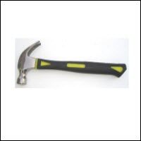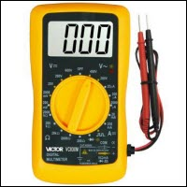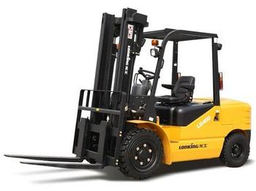

**D E F G**

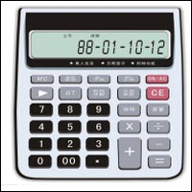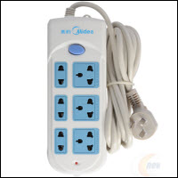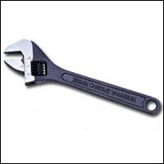

Example: 0 ( D ) It is a small electronic machine that can add and divide etc.

21. ( ) It is a tool used for measuring electricity.

22. ( ) It is a tool with a handle and a heavy metal head, used for breaking things.

23. ( ) It is a tool used for turning a small piece of metal, like nut, to make it tight or loose.

24. ( ) It is a machine with special equipment on the front for moving andlifting heavy objects.

25. ( ) It is a tool used for rubbing hard objects to make them smooth,shape them, or cut through them.

**Task 5**

**Directions:** *In this section, you will read four texts and six questions. Match the text and the question and fill in the brackets with the letters. There is one example.（在本节中，你将看到4个文本和6个问题。请将这些文本与相应的问题匹配起来，并把与文本对应的字母填在括号内。请参照示例。）*

**A B**

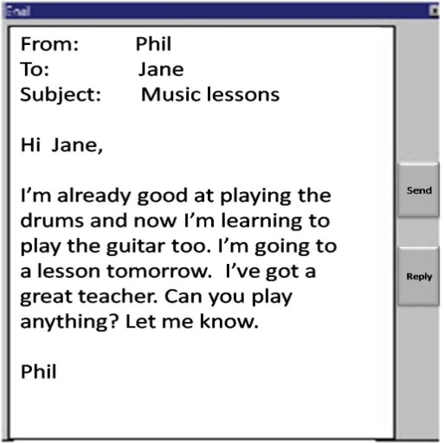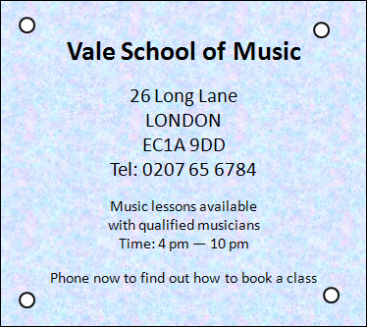

**CD**

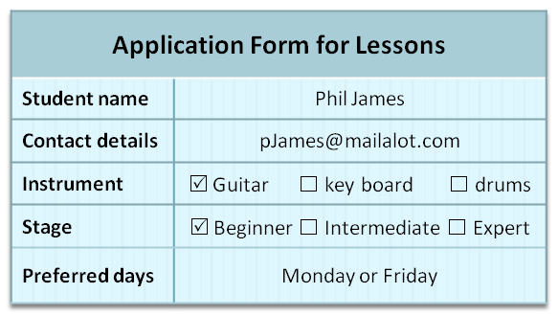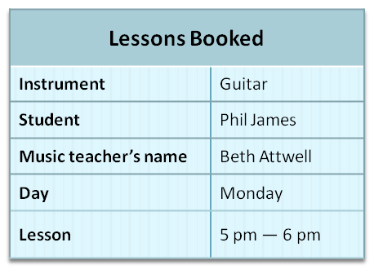

**Which text tells you:**

|  |  |  |
| --- | --- | --- |
| Example: 0 | the name of Phil’s friend? | ( A ) |
| 26. | the time of Phil’s lesson? | ( ) |
| 27. | information on how well Phil plays the guitar? | ( ) |
| 28. | the name of the music teacher? | ( ) |
| 29. | information on how to find the music school? | ( ) |
| 30. | how many instruments Phil can play? | ( ) |

**Task 6**

**Directions:** *In this section, you will read six short descriptions and seven pieces of information related to them. Match the description and the related information and fill in the brackets with the letters. Notice there is one extra piece of information you do not need. There is one example.（在本节中，你将读到6段描述和7条相关的信息。请将这些描述和相应的信息匹配起来，并把与信息对应的字母填在括号内。注意有一条冗余信息。请参照示例。）*

Online Training Courses

***A.*** *Beauty Courses*

***B.*** *Computer Science*

**C.** *Career Management*

***D.*** *Preschool Education*

***E.*** *Art and Design Course*

***F.*** *Customer Service Skills*

***G.*** *Accounting for Companies*

Example:

0. (D)

Lynne loves children and wants to teach them singing and dancing. She’d like to work in a kindergarten.

31. ()

Donald has been working as a financial assistant. He wants to learn more about tax and account keeping services.

32. [](http://image.jike.com/detail?did=1719995170591562632&pos=127&num=36&q=%E4%BA%BA%E7%89%A9%E5%9B%BE%E7%89%87%E7%BD%91&fm=rs)()

Cathy wants to develop her knowledge, skills and experience in her work and gain success in the future.

33. ()

Robert likes to write different kinds of computer software and use mathematics to analyze a system.

34. 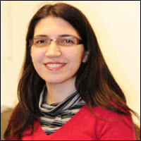()

Sally works in a customer service center. She needs better communication skills while dealing with customers.

35. ()

Judy is interested in painting and design. She is trying to find a job in a website design company.

**Task 7**

**Directions:** *In this section, you will read two passages and five questions about each passage. Choose the best answer for each question.（阅读下面两篇短文，每篇5个问题，请从每题所给的A、B、C三个选项中选出最佳答案。）*

**A**

A robot is a machine that senses the world, processes the sensor information with a computer and then does something in response to that information (such as moving or turning).

A robot isn’t just a computer. A desktop computer can “sense” that you are typing or moving the mouse, but the computer itself doesn’t move or act in the physical world.

In fact, robots are used all over the world right now. Robots build cars, clean houses, help soldiers and doctors, are played with by kids and explore other planets. They may not look like the robots we see in the movies but they are still doing important jobs. Robots can also be very powerful tools for learning. Kids all over the United States are using robots in their classrooms and out-of-school activities to help them learn science, technology, engineering, and math (STEM) topics in new and innovative ways.

36.According to the passage, a robot is a machine that can ______.  
 A. feel the people

B. act according to the instruction

C. know its way to somewhere  
37. In order to let the robot move, you only have to ______ .  
 A. click the mouse

B. move the computer

C. do nothing  
38. According to the passage, robots are now ________used in the society.  
 A. deeply

B. quickly

C. widely

39. Robots can even be sent into space to_______ other planets.

A. examine

B. invent

C. explore  
40. Kids are using robots more and more for ______ .  
 A. study

B. cleaning

C. movies

**B**

Movie fans know that Superman does not really fly. And, in the movie *Superman Returns*, another trick is played on people. The man they see flying is not real. He is a virtual actor. How is the actor created? The first step is to have a real person stand in a room. The room is called a light stage. A computer then gets the outlines and shapes of his/her face and records how they throw off light. The light stage permits actors to be turned into digital versions of themselves.

The real world could soon be using a similar technology. Computer experts are developing a 3-D video teleconferencing system. It would send a video image of a person into a meeting room. That image would be able to work with people in the room. And people would see the image in 3-D without special eyeglasses.Paul Debevec, an expert, believes the business world will begin to use 3-D video teleconferencing in the next five years.

The 3-D images will also be shown on special screens in classrooms or museums to answer questions. In 10 years, we may be able to play 3-D video games without special glasses.

41. What is the trick in the movie *Superman Returns*?

A. The flying man is actually a robot.

B. The actor really flies in the movie.

C. The flying man is a virtual actor.

42. What is created in a light stage?

A. A movie scene.

B. An image of actor.

C. A virtual actor.

43. How does a 3-D video teleconferencing system work?

A. It could record the sound and image of people in a meeting room.

B. It could send a 3-D video image of a person into a meeting room.

C. People in different places can see each other with special glasses.

44. Which field will probably begin to use the 3-D technology in five years?

A. Business world.

B. Movie-making industry.

C. School teaching.

45. What’s the best title for this passage?

A. 3-D goes from movies to real world.

B. 3-D plays an important role in business.

C. An introduction to creating 3-D images.

**Task 8**

**Direction:** *In this section, you will read a text and choose the best word(s) for each numbered blank.（阅读下面的短文，并从每题所给的A、B、C三个选项中选出最佳答案。）*

Today is my first day to work as an assistant in a property management company, which provides renting, cleaning and repairing services to the community. I was lucky to meet a very kind person __46__ helped me a lot. I just __47__ working when I saw an old man __48__ in the garden. I went up to __49__ him. He told me that he __50__ some pet waste in the lawn. He thought that not only the property management company but also people living here were __51__ for the environment of our community. When he got to know I was a new hand, he __52__ at me and began to help me __53__ the garden. With his help, I __54__ my work this morning quickly and became familiar with the community. I really appreciate his __55__.

46. A. who B. which C. he

47. A. enjoyed B. started C. practiced

48. A. walk B. to walk C. famous

49. A. greet B. tell C. shouted

50. A. put down B. found out C. clean

51. A. grateful B. responsible C. finished

52. A. laughed B. smiled C. family

53. A. dirty B. move C. walking

54. A. knew B. began C. help

55. A. help B. story C. picked up

**情境交流环节**

**作答要求：**

1. 选手A用英语描述图片内容并阐释个人见解，内容可适当扩展。限时90秒。

2. 选手B用英语回答裁判提出的2个问题。限时90秒。

3.语言表达要观点明确，条理清晰，表述自然、流畅、达意。

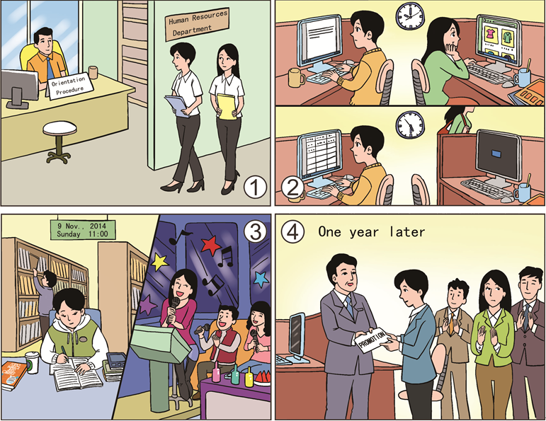

**职场应用环节**

**For Contestant A Only**

**选手A: 美国加州某工厂需进购一台监控器 (security camera)。假设你是该厂设备处主任，手上有工厂对监控器基本功能的要求。你的队友是设备处同事，手上有三款监控器的信息。请与队友沟通，选择一款你们认为最能满足工厂要求的监控器。**

在比赛第一阶段，你需在30分钟内完成：

1. 阅读工厂对监控器的功能要求，填写任务单中的Section 1；

2. 向队友询问三款监控器的相关信息，填写任务单中的Section 2；

3. 与队友讨论，选出一款你们认为最能满足工厂要求的监控器，完成任务单中的Section 3；

4. 准备第二阶段的汇报内容。

备注：任务单仅由选手A填写，供其在赛场陈述时参考。

在比赛第二阶段，你需在3分钟内向裁判汇报任务完成情况，内容需涵盖以下要点：

1) What is your group’s task?

2) Which security camera have you chosenfor the factory?

3) Why have you chosen thissecurity camera? (Please give detailed reasons why you have chosen this security camera and haven’t chosen the other two.)

**For Contestant A Only**

**Please read the requirements for the security camera by the factory.**

Mr. Black,

The security camera we bought in 2000 has turned off several times for no reason. Moreover, it cannot produce clear images in low-light conditions. Our goods were stolen twice last year, but we could not get useful image information from the security camera. So we need to buy a new one as soon as possible. The following are the requirements for the security camera:

• Indoor use

• Can be powered by batteries in case of power failure

• Can produce high-quality video images in very low-light conditions

• Can produce black-and-white video images in total darkness

• Price: within US$400

Yours sincerely,

George King

**For Contestant A Only**

**Worksheet**

**Section 1 Read the requirements by the factory and complete the form.**

|  |  |
| --- | --- |
| **Items** | **Requirements** |
| Power | Can be powered by____________________________________ |
| Working conditions | use  Can work well inconditions and in ____________________________________________________ |
| Price | ____________________________________________________ |
| How soon to use | ____________________________________________________ |

**Section 2 Communicate with Contestant B and complete the following form.**

|  |  |
| --- | --- |
| **Items** | **Information about Each Security Camera** |
| Power | Security Camera A: Powered by ____________________________  Security Camera B: Powered by ____________________________  Security Camera C: Powered by ____________________________ |
| Where to use | Security Camera A: ______________________________________  Security Camera B: ______________________________________  Security Camera C: ______________________________________ |
| Light conditions | Security Camera A: Can produce______________in____________,  and produce_____________in_____________  Security Camera B: ______________________________________  Security Camera C: ______________________________________ |
| Price | Security Camera A: ______________________________________  Security Camera B: ______________________________________  Security Camera C: ______________________________________ |
| More information | Security Camera A: ______________________________________  Security Camera B: ______________________________________  Security Camera C: ______________________________________ |

**Section 3 Discuss with Contestant B and make a decision.**

Which security camera do you choose for the factory?

□Security Camera A□Security Camera B□Security Camera C

**For Contestant B Only**

**选手B: 美国加州某工厂需进购一台监控器 (security camera)。假设你是该厂设备处工作人员，手上有三款监控器的相关信息。你的队友是设备处主任，他手上有工厂对监控器基本功能的要求。请与队友沟通，选择一款你们认为最能满足工厂要求的监控器。**

在比赛第一阶段，你需在30分钟内完成：

1. 认真阅读三种型号的监控器情况介绍，提取相关信息；

2. 与队友沟通，提供其所需信息，协助其完成任务单中的Section 2；

3. 与队友讨论，选出一款你们认为最能满足工厂要求的监控器，协助其完成任务单中的Section 3；

4. 准备第二阶段的答问内容。

备注：任务单仅由选手A填写。

在比赛第二阶段，你需在2分钟内回答裁判的三个问题。回答需与实际任务相结合，表达清楚、有理有据、有逻辑性。其中一个问题是：

Suppose you are a security camera seller, please recommend the security camera you have chosen to your partner, just selecting one or two features to explain.

**For Contestant B Only**

**Please read the following information about the three security cameras and help Contestant A complete the worksheet.**

**Security Camera A**

1. Made for outdoor or indoor use
2. Powered by batteries or electricity

C. Supports monitoring via cell phones or computers

1. Can produce high-quality video images in very low-light conditions
2. Can produce black-and-white video images in completely dark conditions
3. Price: US$340

**Security Camera B**

1. Suitable for use during bad weather
2. Made for outdoor or indoor use
3. Powered by both electricity, and also by batteries (when there is no power)
4. Can produce black-and-white video images in very low-light conditions
5. Changes direction easily
6. Price: US$350

**Security Camera C**

1. Specifically made for indoor use
2. Powered by electricity or batteries
3. Can produce high-quality video images in very low-light conditions, and black-and-white video images in complete darkness
4. Life-long technical support
5. Price: US$380 (plus 10% discount after10 days)

**十、评分标准制定原则、评分方法、评分细则**

（一）评分标准的制订原则

竞赛本着公平、公正、公开的原则，考查参赛选手在通用职场情境下运用英语进行听、说、读、写的综合英语应用能力,跨文化交际能力,以及创新、思辨、沟通、合作、信息处理、解决问题等职业能力。服务类与其他类专业组分别评分，不横向排名。

（二）评分方法

本赛项三个环节总分合计100分，各环节所占比重为：在线测评20%、情境交流40%、职场应用40%。三个环节得分总和为参赛队最终得分，按照得分从高到低决定名次。

1.在线测评环节使用计算机在线测试平台完成，测试内容均为客观题，选手提交试卷后由系统判分，即时公布选手答题结果及成绩；其他环节得分由裁判组统一评定，现场公布选手及团队成绩。

2. 竞赛期间，参赛选手如有不服从裁判和监考人员、扰乱赛场秩序等不文明行为，由裁判长在1—5分范围内酌情扣减其环节相应分数，情节严重者取消其比赛资格，参赛队比赛成绩计为0分。有作弊行为的参赛队比赛成绩计为0分。

（三）评分细则

1. 在线测评，满分20分。选手得分由计算机根据标准答案按百分制给出。团队得分的计算方式为两位选手得分的平均数乘以本环节的加权系数0.2。

2. 情境交流，满分40分，其中：

（1）图片理解（正确理解图片内容，准确把握图片情节，逻辑连贯、完整，明确图片隐含的职业意义）15分；

（2）语言表达（观点明确、合理，叙述条理清晰，表述地道、自然、流畅、达意）10分；

（3）回答提问（正确理解裁判提问，回答有理有据，观点明确，条理清晰，逻辑性强，有说服力）15分；

3. 职场应用，满分40分，其中：

（1）信息理解与加工（准确理解任务要求，对信息内容把握到位，分析、筛选出有用信息）15分；

（2）团队合作与沟通（分工合理，彼此配合、协助，能采用有效的方式进行沟通，实现信息的有效交流，高效有序地完成任务）15分；

（3）任务达成（成功完成任务，对任务完成情况的陈述全面、合理，条理清晰、理由充分，正确理解并回答裁判的问题，说服力强，综合表现优秀）10分。

**十一、奖项设置**

1.团体奖。服务类专业组与其他类专业组分组评定，以各专业组参赛队总数为基数，分设一、二、三等奖，获奖比例分别为10%、20%、30%（小数点后四舍五入）；获得团体奖的参赛队队员获相应等级的奖项。

2.获得一等奖的参赛队指导教师由组委会颁发优秀指导教师证书。

**十二、技术规范**

《中等职业学校英语教学大纲》

**十三、建议使用的比赛器材、技术平台和场地要求**

1. 成熟的“语言测试与训练系统”：用于在线测评。

2. 电脑：每位参赛选手1台，需配备耳机，用于在线测评。

3. 演讲台：用于开闭幕式嘉宾发言。

4. 音响设备、投影设备、录像设备：用于情境交流和职场应用。

5. 话筒：情境交流6个，职场应用6个。

6. 场地：每组别各需要1个候赛室，10个备赛室，1个赛场。

**十四、安全保障**

（一）比赛环境

1.赛前组织专人对比赛现场、住宿场所和交通保障进行考察，对安全工作提出明确要求。赛场的布置，赛场内的器材、设备，应符合国家有关安全规定。如有必要，进行赛场仿真模拟测试，以发现可能出现的问题。承办单位赛前须按照要求排除安全隐患。

2.赛场周围要设立警戒线，防止无关人员进入发生意外事件。比赛现场内应参照相关职业岗位的要求为选手提供必要的劳动保护。在具有危险性的操作环节，裁判员要严防选手出现错误操作。

3.承办单位应提供保证应急预案实施的条件。对于比赛内容涉及高空作业、可能有坠物、大用电量、易发生火灾等情况的赛项，必须明确制度和预案，并配备急救人员与设施。

4. 制定开放赛场和体验区的人员疏导方案。赛场环境中存在人员密集、车流人流交错的区域，除了设置齐全的指示标志外，须增加引导人员，并开辟备用通道。

5.大赛期间，承办单位须在赛场管理的关键岗位，增加力量，建立安全管理日志。

6.参赛选手进入赛位、赛事裁判工作人员进入工作场所，严禁携带通讯、照相摄录设备，禁止携带记录用具。如确有需要，由赛场统一配置、统一管理。赛项可根据需要配置安检设备对进入赛场重要部位的人员进行安检。

（二）生活条件

1.比赛期间，原则上统一安排参赛选手和指导教师食宿。承办单位须尊重少数民族的信仰及文化，根据国家相关的民族政策，安排好少数民族选手和教师的饮食起居。

2.比赛期间安排的住宿地应具有宾馆/住宿经营许可资质。以学校宿舍作为住宿地的，大赛期间的住宿、卫生、饮食安全等由执委会和提供宿舍的学校共同负责。

3.大赛期间有组织的参观和观摩活动的交通安全由执委会负责。执委会和承办单位须保证比赛期间选手、指导教师和裁判员、工作人员的交通安全。

4.各赛项的安全管理，除了可以采取必要的安全隔离措施外，应严格遵守国家相关法律法规，保护个人隐私和人身自由。

（三）组队责任

1.各学校组织代表队时，须安排为参赛选手购买大赛期间的人身意外伤害保险。

2.各学校代表队组成后，须制定相关管理制度，并对所有选手、指导教师进行安全教育。

3.各参赛队伍须加强对参与比赛人员的安全管理，实现与赛场安全管理的对接。

（四）应急处理

比赛期间发生意外事故，发现者应第一时间报告执委会，同时采取措施避免事态扩大。执委会应立即启动预案予以解决并报告组委会。赛项出现重大安全问题可以停赛，是否停赛由执委会决定。事后，执委会应向组委会报告详细情况。

（五）处罚措施

1.因参赛队伍原因造成重大安全事故的，取消其获奖资格。

2.参赛队伍有发生重大安全事故隐患，经赛场工作人员提示、警告无效的，可取消其继续比赛的资格。

3.赛事工作人员违规的，按照相应的制度追究责任。情节恶劣并造成重大安全事故的，由司法机关追究相应法律责任。

**十五、经费概算**

|  |  |  |  |
| --- | --- | --- | --- |
| **收入概算** | **支出项目** | | **金额概算** |
| 统筹赛项经费拨付  40万 | 1 | 试题库研发（含绘图） | 16万 |
| 2 | 会务费（如：研讨会、赛项说明会等） | 11万 |
| 3 | 赛项专家工作费 | 6万 |
| 4 | 监督组、裁判组费用  （裁判组包括：仲裁、加密裁判、裁判长和打分裁判） | 10万 |
| 5 | 赛项服装费（参赛队、裁判、工作人员） | 7万 |
| 6 | 赛项场内宣传 | 10万 |
| 7 | 赛项摄录制与资源转化费 | 10万 |
| 8 | 其他 | 5万 |
|  | 支出合计 | | 75万 |

**十六、比赛组织与管理**

赛项设执行委员会负责竞赛的运行与管理。赛项执委会下设赛项专家组及执委会秘书处。

（一）执行委员会

赛项执行委员会在大赛执委会领导下开展工作，并接受赛项所在分赛区执委会的协调和指导，主要职责包括：全面负责本赛项的筹备与实施工作，编制赛项经费预算，统筹管理赛项经费使用，推荐赛项专家组成员、裁判和仲裁人员，负责赛项资源转化、安全保障等工作。

（二）专家组

赛项专家工作组在赛项执委会领导下开展工作，负责本赛项技术文件编撰、赛题设计、赛场设计、赛事咨询、竞赛成绩分析和技术点评、资源转化、裁判人员培训等竞赛技术工作；负责赛项展示体验及宣传方案设计。

（三）执委会秘书处

赛项执委会秘书处根据分工成立多个工作小组，负责具体落实各个环节的筹备与实施工作。

**十七、教学资源转化建设方案**

举办本赛项的重要目的是优化教学资源配置，将赛项内容转化为教学成果，以此带动中职英语教学改革。

1.整合优质赛题、获奖选手视频、专家点评视频、指导教师访谈视频等资源，建立资源库，将优质的数字化竞赛资源向公众免费开放，以形象、立体、直观的方式展现大赛成果，为人才培养提供直观可借鉴的素材。

2. 发掘并推广把通用职场情境下的英语综合应用能力及基本职业能力融入到教学中的优质课，推动中职教育教学改革。计划于2019年陆续推出相关教材及教学资源。

3. 搭建优秀指导教师、优秀选手交流平台，加强全国中职师生的沟通与交流，分享经验，共同提高。计划邀请优秀教师、选手代表，参加方案申报单位2018年举办的各类相关学术会议、教师培训及交流活动。

4. 依托中国职业技术教育学会、全国基础外语教育研究培训中心和《中国外语》核心期刊等机构和媒体，于2018年赛项比赛结束后两个月内，组织相关主题报道和宣传活动，更好地推广竞赛成果。

5.结合赛项的实施情况和参赛队的表现，并根据从参赛师生、裁判处收集到的反馈意见，详细分析，严谨论证，邀请专家进行指导，明确赛项所反映的当今中等职业教育教学与人才培养方面存在的问题，并形成有针对性的意见和建议，用以指导日后的教材出版、教师培训、赛事设计等工作。

**十八、筹备工作进度时间表**

|  |  |
| --- | --- |
| **时间节点** | **工作项** |
| 2018年1月初 | 组建专家组 |
| 2018年1月初 | 方案细节调整 |
| 2018年1月中 | 确定比赛场地及赛场规划 |
| 2018年1月底 | 召开专家组会议，提交正式公布的竞赛规程 |
| 2018年1月底 | 成立技术组，研究与竞赛有关的细节问题并分工准备，样题设计 |
| 2018年2月底 | 测试平台检测 |
| 2018年2月底 | 样题及评分标准公布 |
| 2018年2月底 | 裁判申报 |
| 2018年3月初 | 讨论赛题 |
| 2018年3月底 | 确定裁判 |
| 2018年3月底 | 参赛队报名截止 |
| 2018年3月底 | 比赛场地基础条件布置完毕 |
| 2018年3月底 | 测试平台上线 |
| 2018年4月初 | 裁判培训完成 |
| 2018年4月初 | 所有赛项文件汇总报秘书处 |
| 2018年4月初 | 赛题确定 |
| 2018年4月 | 裁判及监考人员培训 |
| 2018年4月 | 赛前答疑 |
| 2018年5月 | 开赛 |
| 2018年5月底 | 提交竞赛结果 |
| 2018年6月底 | 竞赛过程文件、中职赛项成果汇总材料报相关单位 |
| 注：正式比赛时间安排以教育部统一安排为准，以上时间仅为参考。 | |

**十九、裁判人员建议**

按照大赛裁判人员有关要求遴选裁判组。具体要求如下：

|  |  |  |  |  |  |
| --- | --- | --- | --- | --- | --- |
| **序号** | **组别** | **专业技术方向** | **知识能力要求** | **专业技术职称**  **（职业资格等级）** | **人数** |
| 1 | 服务类 | 外语 | 英语 | 高级 | 5 |
| 2 | 服务类 | 管理 | 人力资源或管理 | 企业人士 | 2 |
| 3 | 其他类 | 外语 | 英语 | 高级 | 5 |
| 4 | 其他类 | 管理 | 人力资源或管理 | 企业人士 | 2 |
| 裁判总人数 | | | | | 14 |

**二十、其他**

申报单位联系人：

|  |  |  |  |  |
| --- | --- | --- | --- | --- |
| **组别** | **姓名** | **手机号码** | **办公电话** | **电子邮箱** |
| 服务类 | 贾巍巍 | 13911606073 | 010-58551809 | jiaww@hep.com.cn |
| 其他类 | 李淑静 | 13911719903 | 010-88819682 | lisj@fltrp.com |